|  |  |  |  |  |  |
| --- | --- | --- | --- | --- | --- |
| Date | …. | | | Tester Name | Alyssa Johnson |
| Environment | Penfax - Test | | | Login used |  |
| Operating System | Select OS | Version: | Update: | | |
| Software Used | Select Software | Version: | Update: | | |
| Select Software | Version: | Update: | | |
| Release version | 22.3.0 | | | | |
| Title | E24.03 | | | | |
| Test Type | Regression | | | | |
| Test Scenario | Run RL2 Tax Slip Batch | | | | |
|  |  | | | | |
| Expected Results | 1. Verify individual pdf’s as well as mass pdf is produced and displays all the members included in batch 2. Verify xml is produced and displays all the members included in batch 3. Verify randomly for some members the payments (confirm members with both types of payments - lump sum and scheduled payment) 4. Verify appropriate Quebec taxes are generated on correct tax slip box 5. Verify personal information like address, SIN, country codes etc. are correctly populated on the Tax slip 6. Verify the same Sid’s are also included on T4A batch such that Quebec members receive both , a T4A as well a RL2 7. After step 7 verify tax slip is saved on member communications 8. After step 8 verify tax slip is available to members in PLANet. | | | | |
| Pass/Fail | Pass | | | JIRA# | N/A |

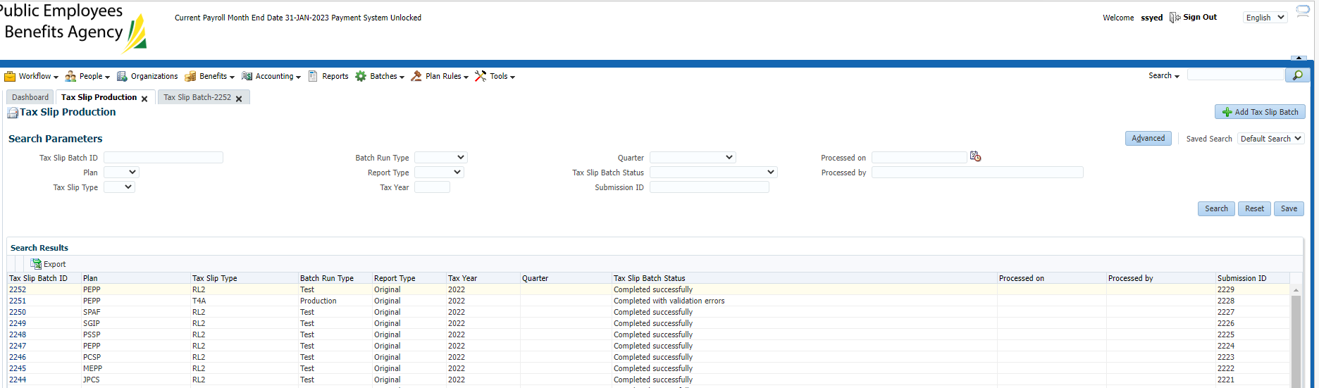

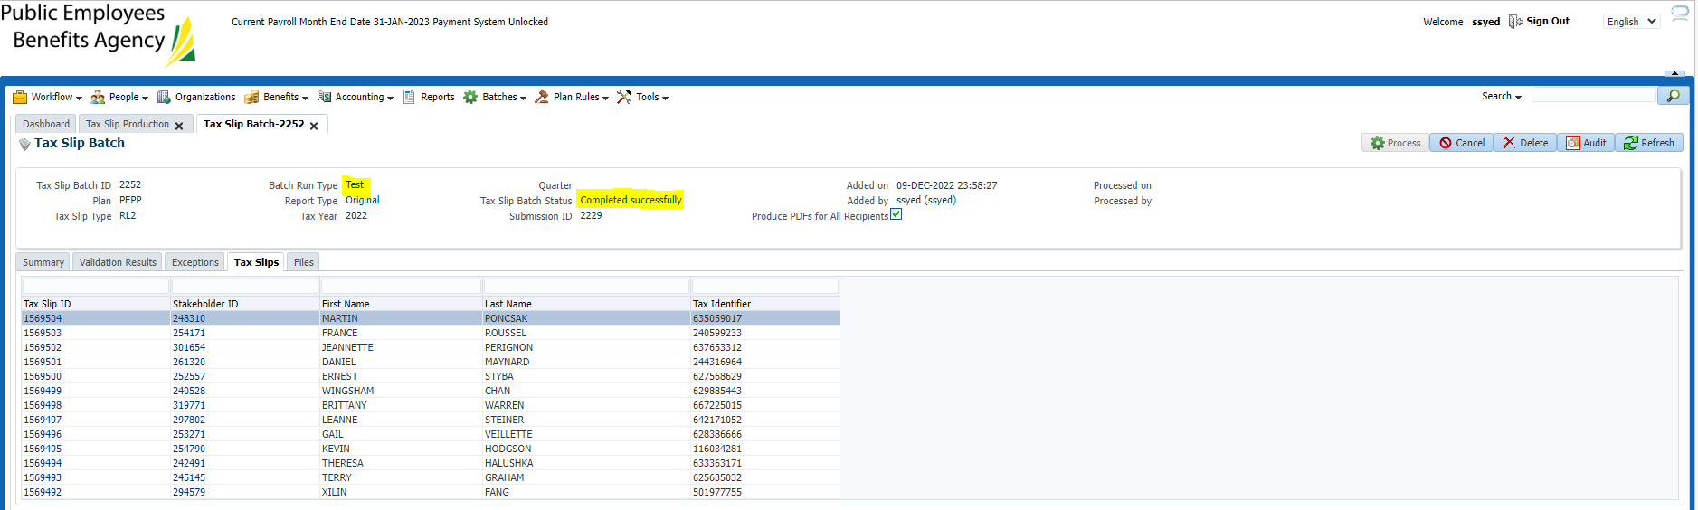

Process tax slip in production (instead of test):

Enter information as below, click save.

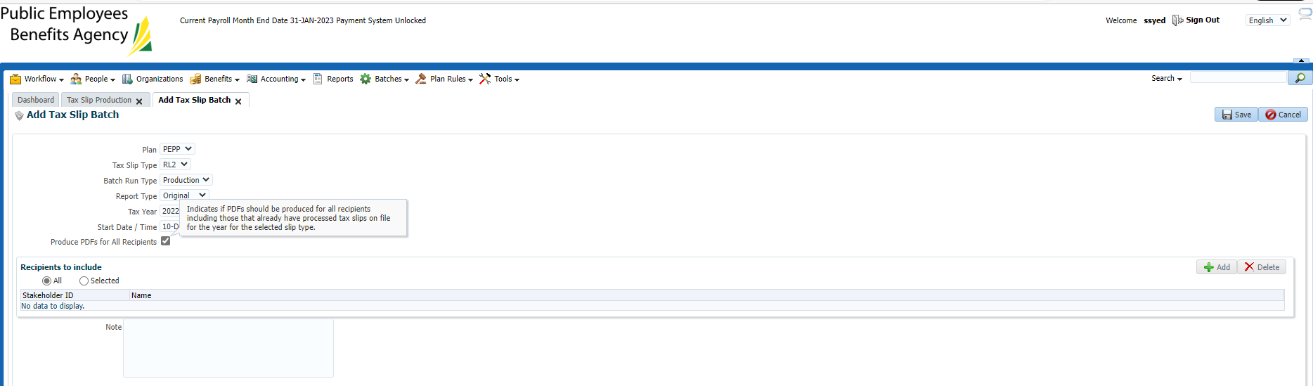

Hit refresh until the batch status shows as “completed successfully”

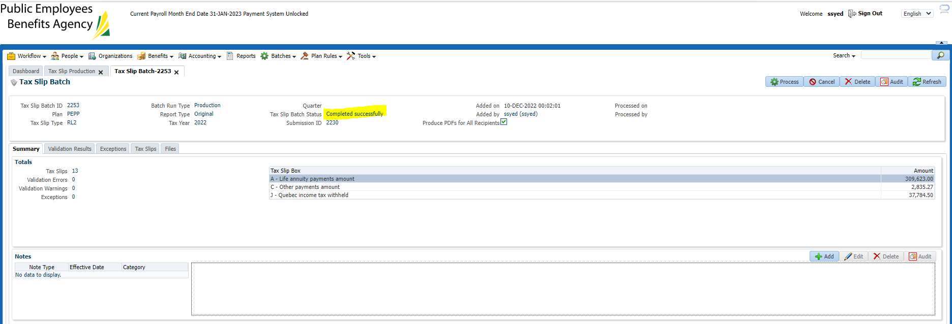

Then click “process” which will no longer be greyed out

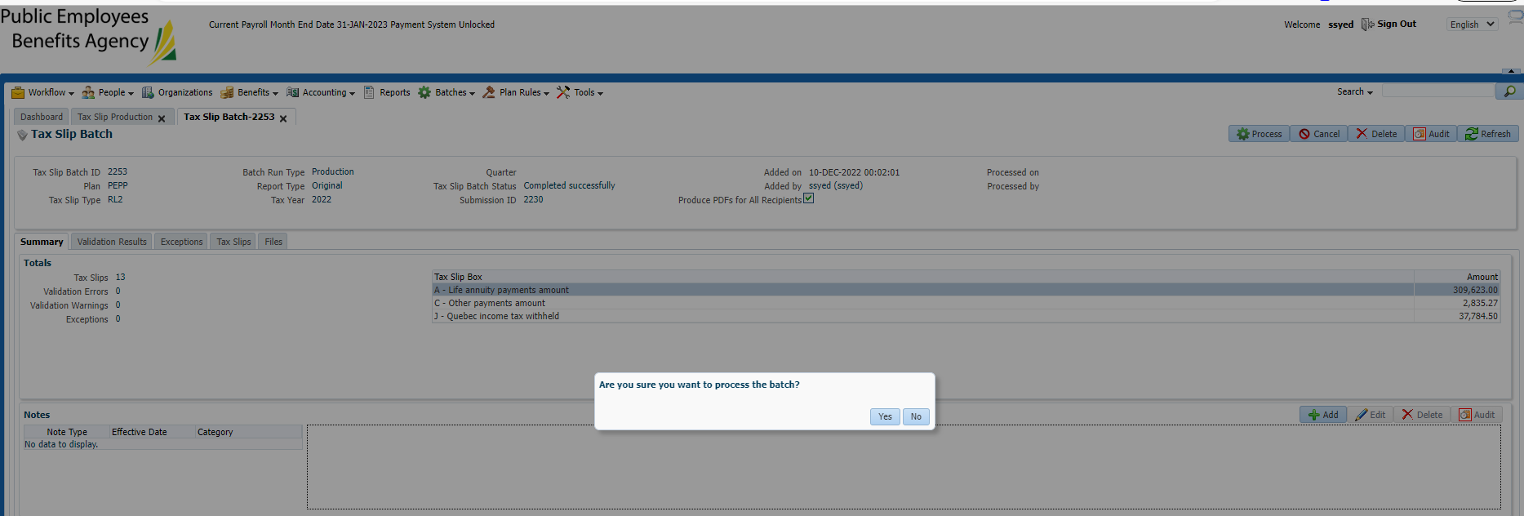

Click yes.

Confirm that there is a PDF with all files & PDF for each individual tax slip:

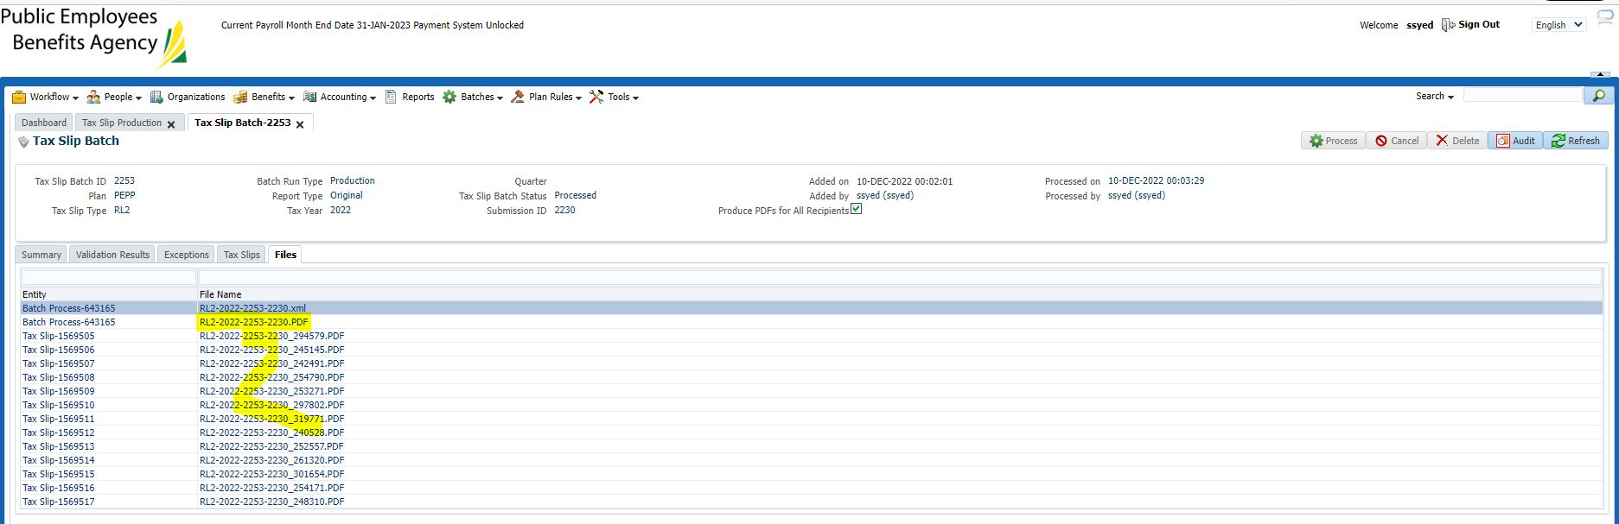

Verify a few members:

Member 1 - SID 248310 (lump sum’s only)

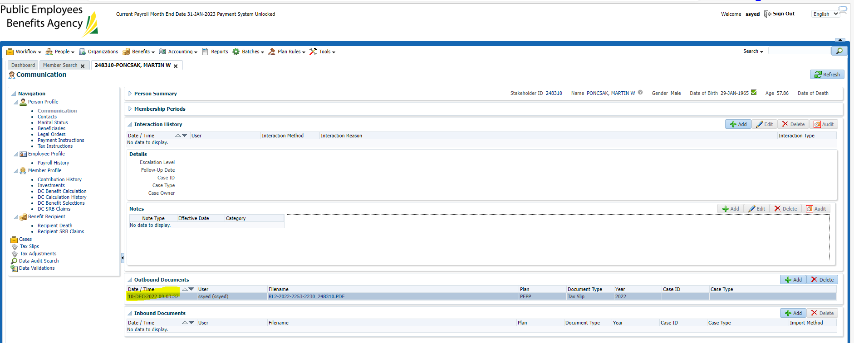

Showing under tax slips (just communications)- Checked overnight

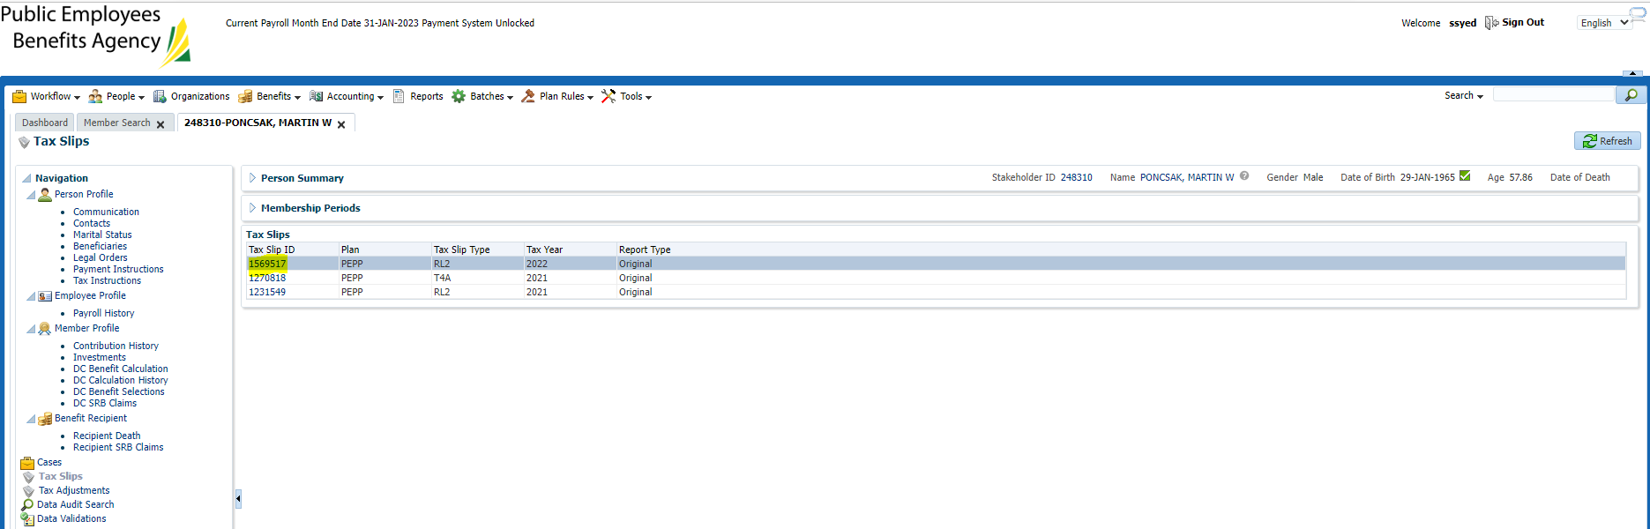

Confirm amount and total taxes withdrawn matches Penfax:

Boxes that are filled in on this tax slip match previous years.

SIN and personal information correct.

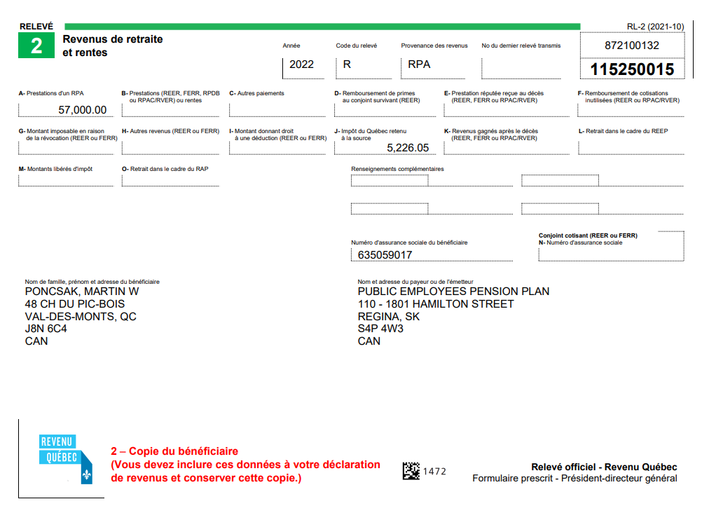

Total income: 57k shows correctly

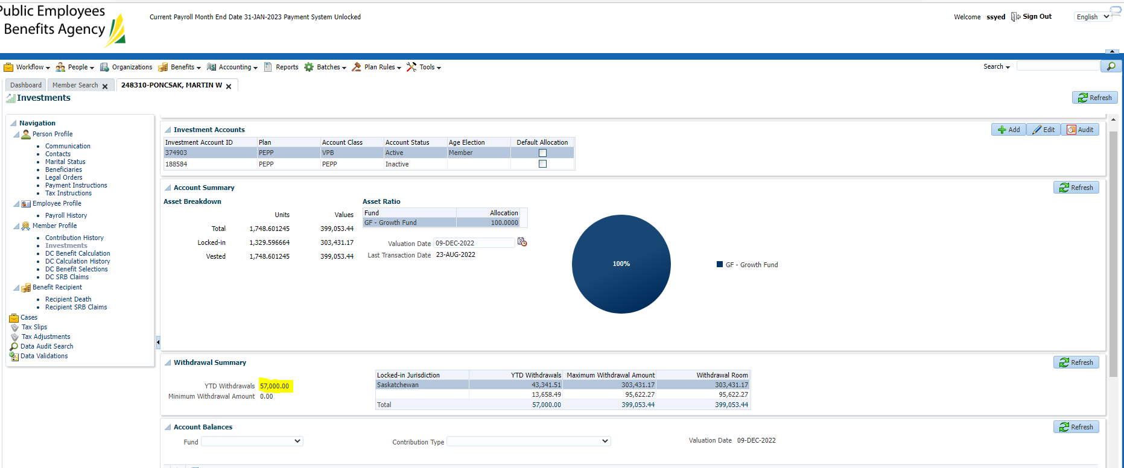

Taxes made up of three payments:

Payment 1

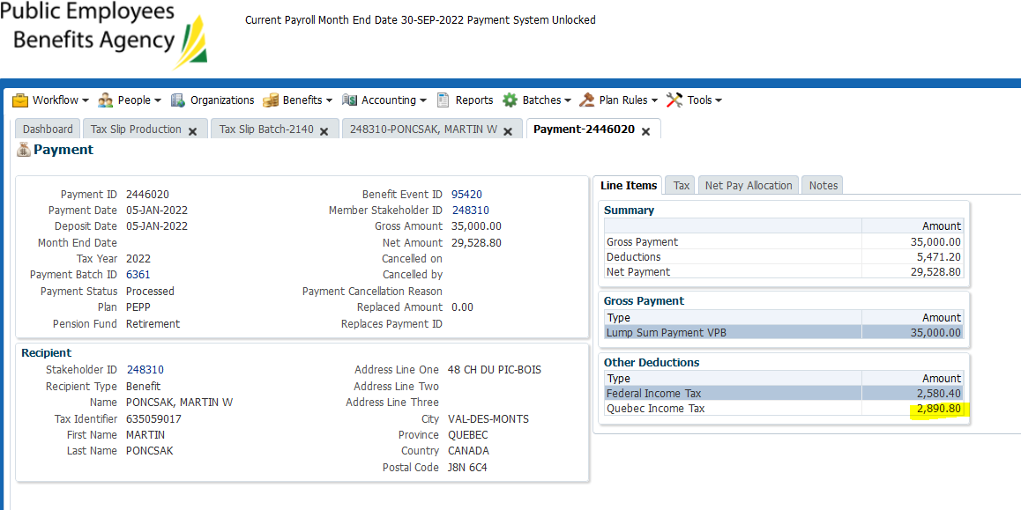

Payment 2

No tax taken off of march 2022 payment (known issue – PlaNet lump sum tax issue – now fixed)

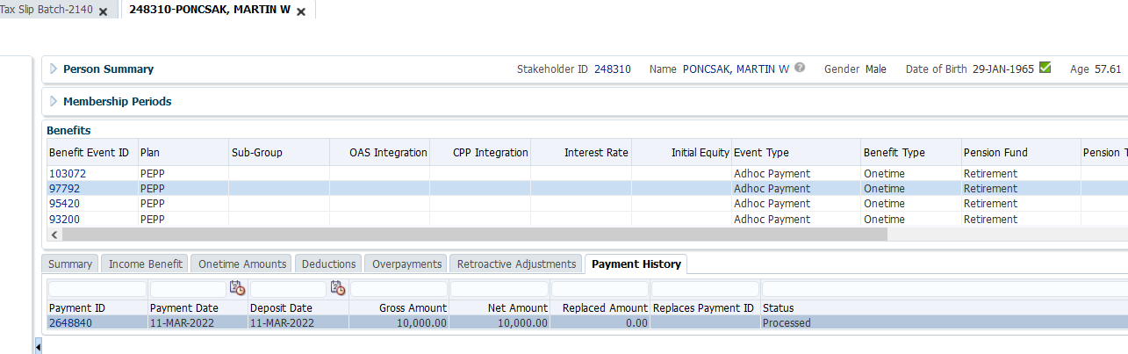

Payment 3

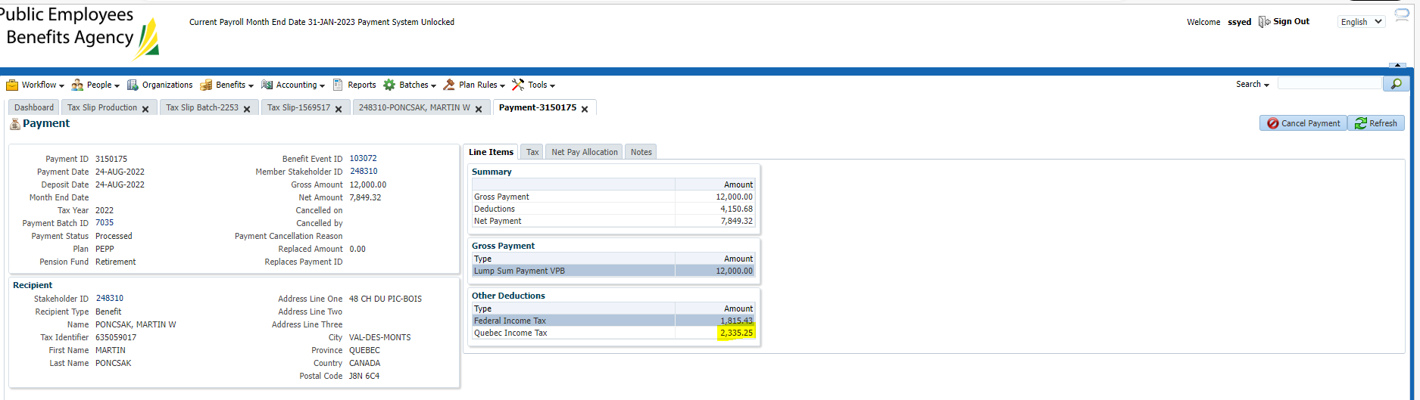

Total tax taken off matches tax slip:

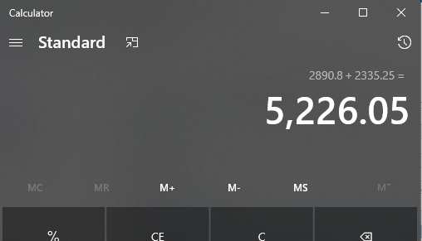

Member 2 – SID 301654 (scheduled payments)

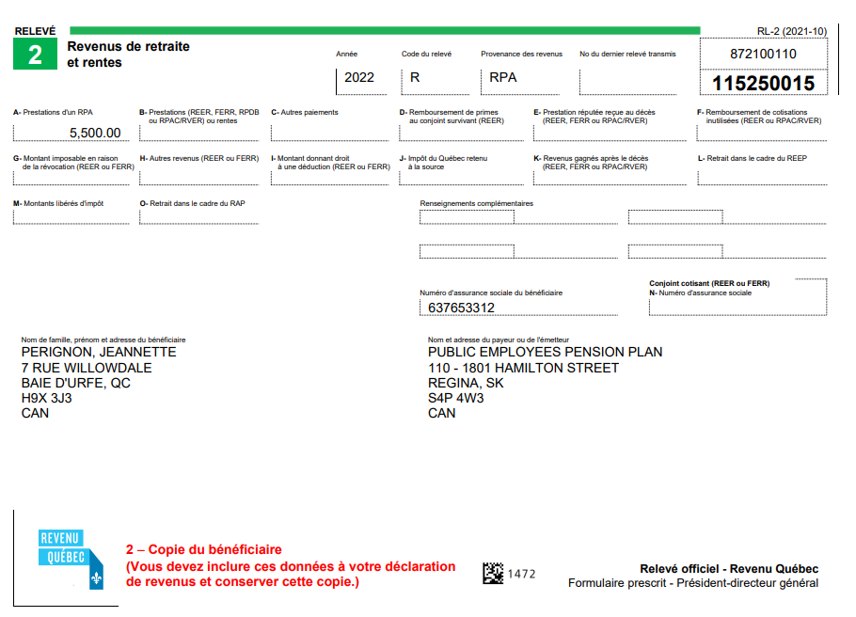

Something is wonky with the August scheduled payment, it’s not showing in benefit recipient and thus not being reflected on the tax slip. To Date withdrawal amount is 4k (not 3500). Fixed issue, problem with August payroll – RL2 is correct when compared to benefit recipient.

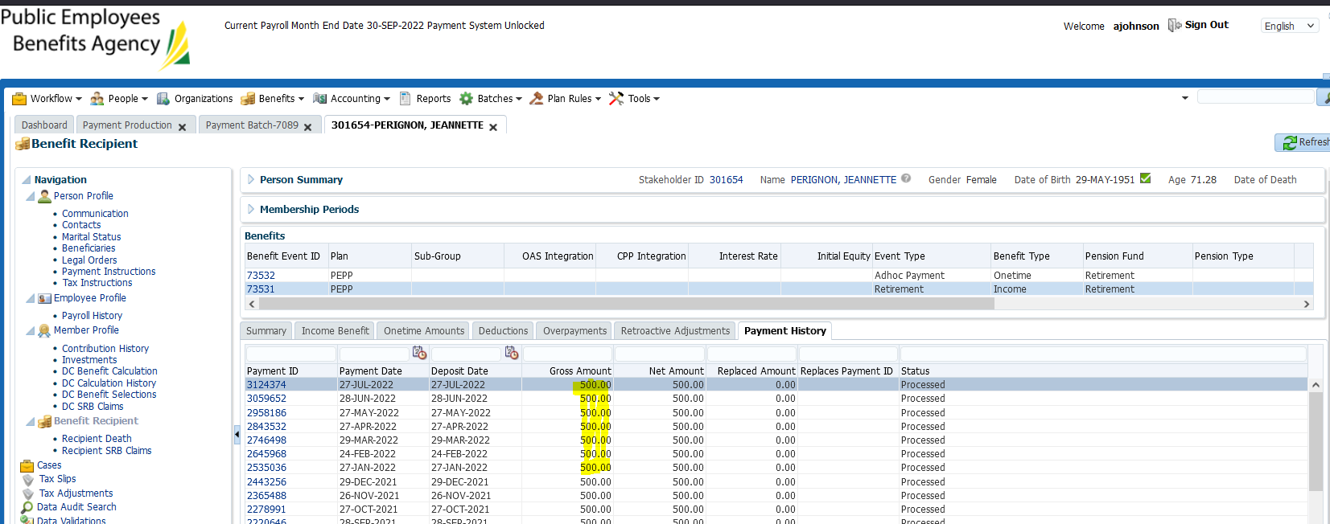

Log into PlaNet admin portal, search the MKEY and hit support mode:

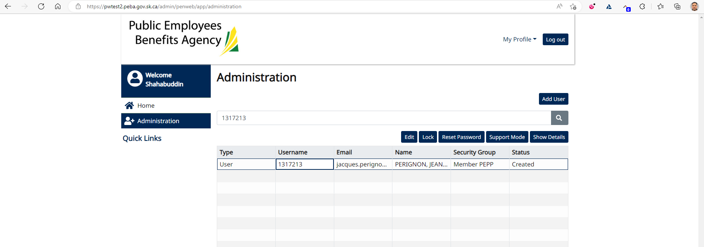

Incorrect file name – should be RL2 however it’s showing 2022 T4A

Last year’s RL2 is also being labeled a T4A – sending email to Steve Green to see if this can be fixed in house – also sending JEA ticket regarding this issue. Will test in training region prior to sending ticket.

PEBA 6609 - Ticket

